(R)Markdown

Wojciech Hardy; Łukasz Nawaro

3/23/22

# Three key elements

## The YAML header

At the very top. Stores author and document information, configuration, global options, inputs, styles, format specifications, etc. This document uses:

## Markdown

The markup language, with easy and nice editing options.

## Code chunks

Where the magic happens - codes whose output becomes a part of the document.

Let’s start with Markdown!

# Basic formatting

Some basic text formatting includes *Italics* or _Italics_ (*Italics*) and **Bold** or __Bold__ (**Bold**) text.

`Space between lines to break a paragraph

Like so`

Space between lines to break a paragraph

Like so

Or end a line with a double space to break without starting a new paragraph

Or end a line with a double space to break  
without starting a new paragraph

Superscripts can be done like so: R^2^ R2

Subscripts can be done like so: H~2~O H2O

# Headers

# Header 1

# Header 1

## Header 2

## Header 2

### Header 3

### Header 3

#### Header 4

#### Header 4

##### Header 5

##### Header 5

# Lists

## Ordered

1. Item 1

2. Item 2

2. Item 3 # Note the error in numbering

1. Item 1
2. Item 2
3. Item 3 # It's fine here though

## Unordered

* Item

* Another item

* Item
* Another item

## Subitems

1. Item 1
   * Item 2
   * Item 3

# Tables

| Day | Hour | Group |
| --- | --- | --- |
| Wednesday | 9:45 | 1 |
| Thursday | 16:45 | 2 |
| Thursday | 18:30 | 3 |

# Equations

You can insert equations with the same syntax as in LaTeX. E.g. within a sentence $ \sum (x + 1) $ $∑\left(x+1\right)$ or as standalone with double $$ at start and finish

$$\int_{−∞}^{∞}{1}/\left(b−a\right)dx$$

# Code chunks customisation

([Partially taken from here](https://bookdown.org/yihui/rmarkdown-cookbook/hide-one.html))

## Chunk naming (for reference)

"You just put the name after the language declaration"

[1] "You just put the name after the language declaration"

## Using variables as parameters

typical_width <- 4  
typical_height <- 4

plot(cars)

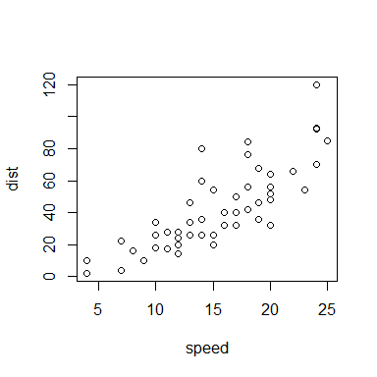

## Using variables within the text 'r variable'

We have previously set a typical width to 4 and the typical height to 4.

## Keeping your report nice and clear

### Hide the source code with echo=FALSE

[1] 2

### Hide messages (e.g. when loading stuff) with message=FALSE

message("You will not see the message.")

### Hide warnings with warning=FALSE

1:2 + 1:3

[1] 2 4 4

### Hide plots with fig.show='hide'

plot(cars)

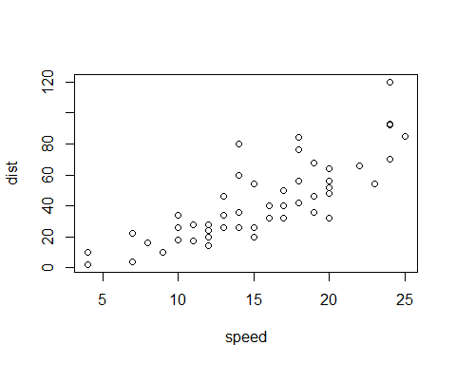

plot(cars)

### Hide everything from the chunk with include=FALSE

### Hide the results with results='hide'

typical_height*typical_width

### Generate Markdown content with R code with results='asis'

for (i in 1:10) {  
 cat("- Item", i, "\n")  
}

* Item 1
* Item 2
* Item 3
* Item 4
* Item 5
* Item 6
* Item 7
* Item 8
* Item 9
* Item 10